Dependencies used:

UiPath.System.Activities v23.6.0-preview

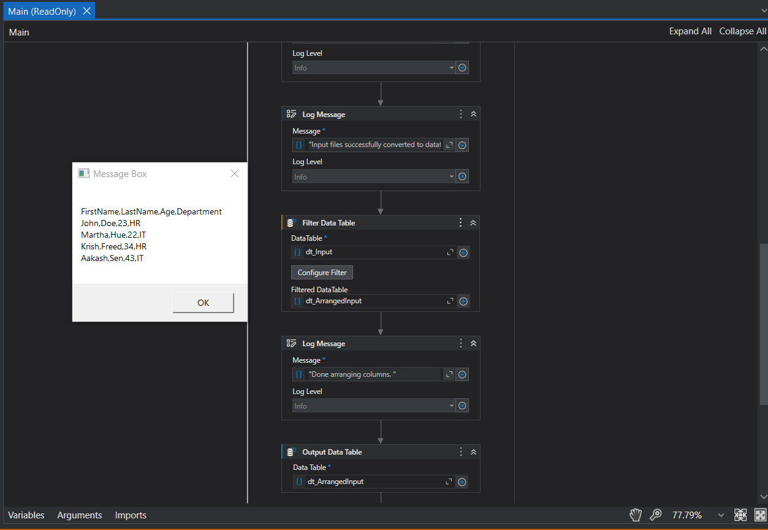

Step1: I use the Read Text File Activity to read the Input text file.

Step 2: Generate Data Table from Text Activity is used to convert the text file to data table.

Step 3: I use Filter Data Table Activity to arrange the columns.

Step 4: Output Data Table Activity to convert back the arranged column that is in Datable to Text or strings.

Step 5: Message Box Activity to output the arranged text files.

Note: The Log message activity displays steps or action of the next activity.